
FOR IMMEDIATE RELEASE:

ANTIGUA AND BARBUDA CELEBRATES SIGNIFICANT MILESTONE WITH LAUNCH OF ‘COME HOME IN DECEMBER’ DIASPORA SWEEPSTAKES
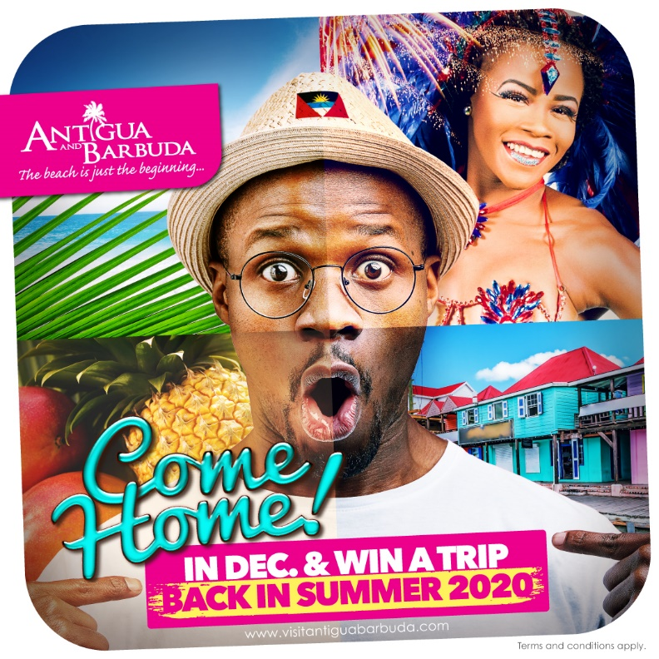

(Photo Caption: The Antigua and Barbuda Tourism Authority's 'Come Home' sweepstakes is geared towards the Antigua and Barbuda diaspora)

(ST. JOHN’S ANTIGUA, NOVEMBER 20, 2019) - Following a dynamic year of award-winning marketing campaigns, new events, and hotel openings, The Antigua and Barbuda Tourism Authority is excited to be celebrating an even greater milestone. By December 2019, Antigua and Barbuda Tourism stayover arrivals would have reached over 300,000. And, with the launch of a new ‘Come home' sweepstakes, the Antigua and Barbuda Tourism Authority is inviting the Antiguan and Barbudan diaspora to join in on the celebrations.

“The destination has received tremendous growth since 2018, and we are proud to know that by December 2019, we would have met and surpassed our target of 300,000 stay-over visitor arrivals,” said Antigua and Barbuda Minister of Tourism, The Honourable Charles Fernandez. “We have to recognise each and every one employed in the tourism industry, who have welcomed visitors to our shores and whose deliverance of quality customer care ensures our visitors have an amazing experience while they are here.”

“Reaching 300,000 stay-over tourism arrivals is a significant milestone,” said CEO of the Antigua and Barbuda Tourism Authority Colin C. James. “We have incredible partnerships with stakeholders throughout the industry, who have been instrumental in bringing us to this milestone, and who are as committed as we are to driving tourism growth.”

As Antigua and Barbuda Tourism officials push to reach the 300,000 mark, the Antigua and Barbuda Tourism Authority has launched a sweepstake specifically targeted to the global diaspora.

“The Antigua and Barbuda diaspora are travelers too. And we are inviting them to ‘Come home in December’ to reconnect with family and friends, and ring in the new decade in Antigua and Barbuda,” said James.

The ‘Come Home in December’ promotion entices Antiguans and Barbudans living abroad to come home during the month of December for a chance to win a free 3-night, 4-day trip back to Antigua during summer of 2020. The promotion officially kicks-off today, November 20, 2019.

The sweepstake is open to citizens of Antigua and Barbuda living abroad and persons of Antiguan and Barbudan heritage. Persons must enter on the www.visitantiguabarbuda.com website and be able to prove booking and travel between December 1 and December 31, 2019. One winner will be selected from each of Antigua and Barbuda’s main source markets in the USA, Canada, U.K. & Europe and the Caribbean. Winners will be selected by random drawing and will be expected to show proof of citizenship and heritage or lineage. Visit www.visitantiguabarbuda.com to enter and for full details and terms and conditions.

###

ABOUT ANTIGUA AND BARBUDA
Antigua (pronounced An-tee'ga) and Barbuda (Bar-byew’da) is located in the heart of the Caribbean Sea. Voted the World Travel Awards 2015, 2016, 2017 and 2018 Caribbean’s Most Romantic Destination, the twin-island paradise offers visitors two uniquely distinct experiences, ideal temperatures year-round, a rich history, vibrant culture, exhilarating excursions, award-winning resorts, mouth-watering cuisine and 365 stunning pink and white-sand beaches - one for every day of the year. The largest of the Leeward Islands, Antigua comprises 108-square miles with rich history and spectacular topography that provides a variety of popular sightseeing opportunities. Nelson’s Dockyard, the only remaining example of a Georgian fort a listed UNESCO World Heritage site, is perhaps the most renowned landmark. Antigua’s tourism events calendar includes the prestigious Antigua Sailing Week, Antigua Classic Yacht Regatta, and the annual Antigua Carnival; known as the Caribbean’s Greatest Summer Festival. Barbuda, Antigua’s smaller sister island, is the ultimate celebrity hideaway. The island lies 27 miles north-east of Antigua and is just a 15-minute plane ride away. Barbuda is known for its untouched 17 mile stretch of pink sand beach and as the home of the largest Frigate Bird Sanctuary in the Western Hemisphere. Find information on Antigua & Barbuda at: www.visitantiguabarbuda.com or follow us on Twitter. http://twitter.com/antiguabarbuda Facebook www.facebook.com/antiguabarbuda; Instagram: www.instagram.com/AntiguaandBarbuda

For media enquiries, please contact:
Maria Blackman
Antigua and Barbuda Tourism Authority
T: 1 (268) 562 7600/464-7601
E: maria.blackman@visitaandb.com

